**Unit 20-Assignment 2-Pizza Delivery**

**Planning and Design:**

**Wireframes:**

Homepage:

Navigation bar to navigate customers to different pages

**Pizza Delivery**

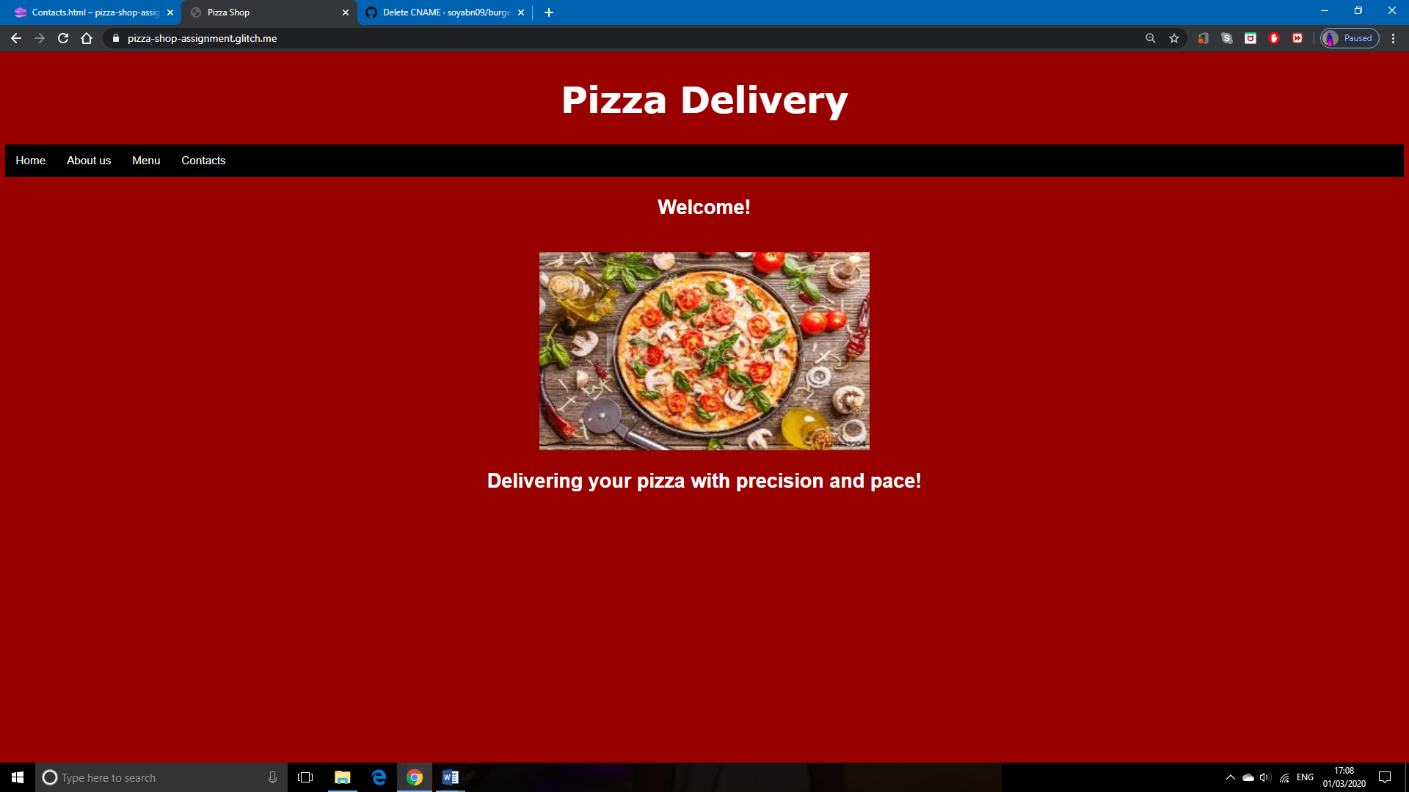

Image of Pizza

Catchy slogan to attract customers

Receipt of customers order.

Booking Page:

**Pizza Delivery**

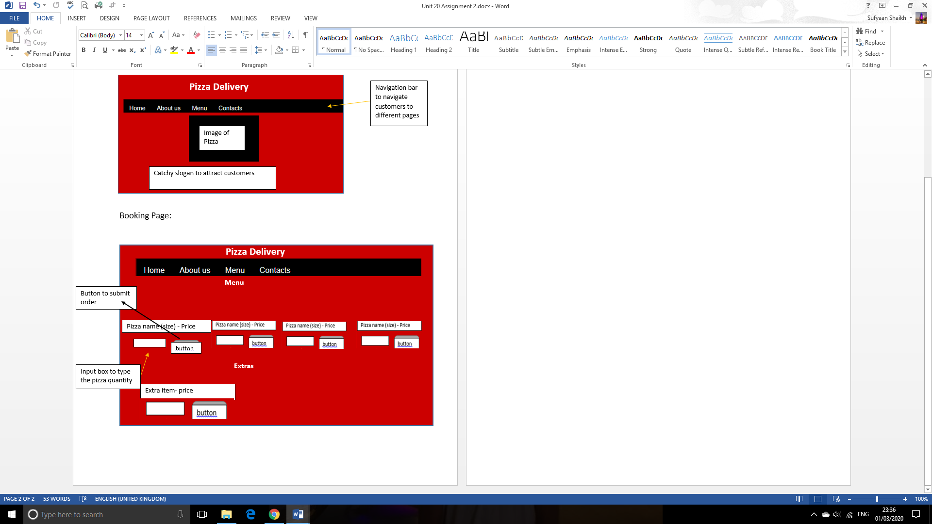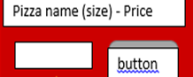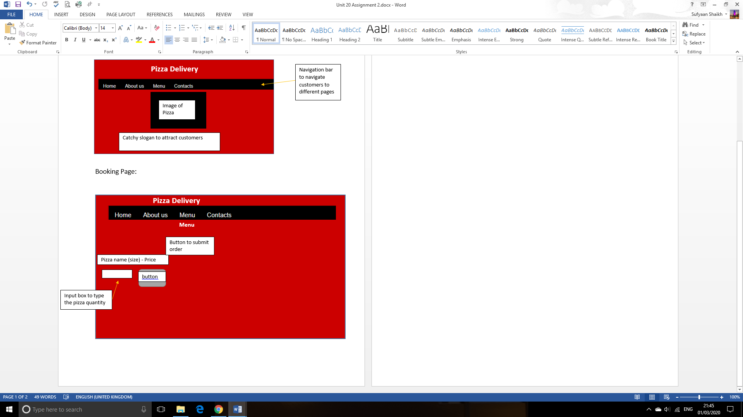

**Customers order**

Product Name Quantity Price Total

Image of Extra item

Image of Extra item

Image of Extra item

Image of Pizza

Image of Pizza

Image of Pizza

Image of Pizza

Input box to type the pizza quantity

Button to submit order

Extra item- price

Button to submit order

button

**Extras**

Input box to type the pizza quantity

Pizza name (size) - Price

**Menu**

Sitemap:

Homepage

About me

Menu

Style guide:

|  |  |
| --- | --- |
| **Fonts** | **Colours** |
| Verdana – used for headings and Paragraphs | Black- hex code-#000000-navigation bar |
| Arial- used for headings and navigation bar | White- hex code-#FFFFFF- headings and paragraphs |
|  | Dark red-hex code-#990000-Background |

**Screenshots of Website:**

URL to Pizza delivery Website-<https://pizza-shop-assignment.glitch.me/index.html>

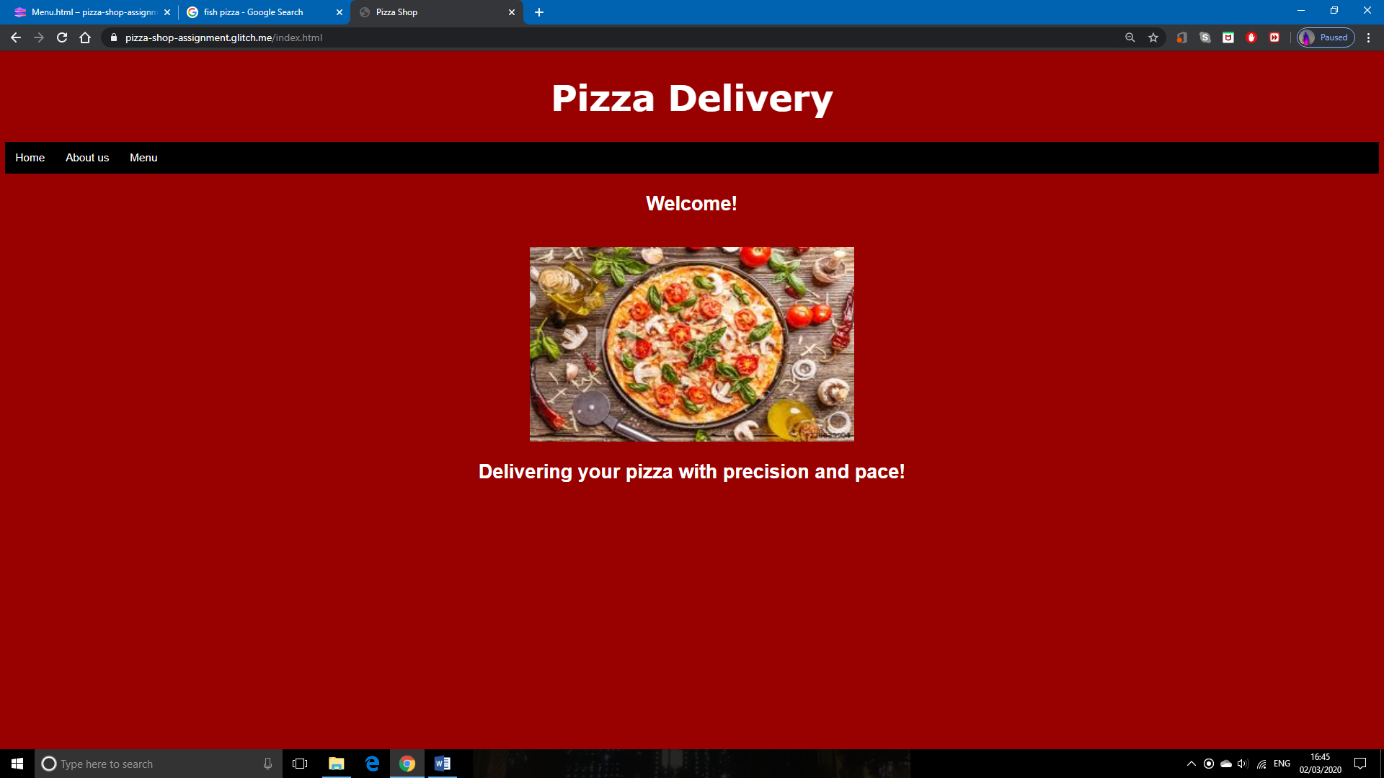

When the user goes to the website it will come up with the homepage where it will welcome the user with the image of the pizza delivery pizzas and a slogan to attract the customers.

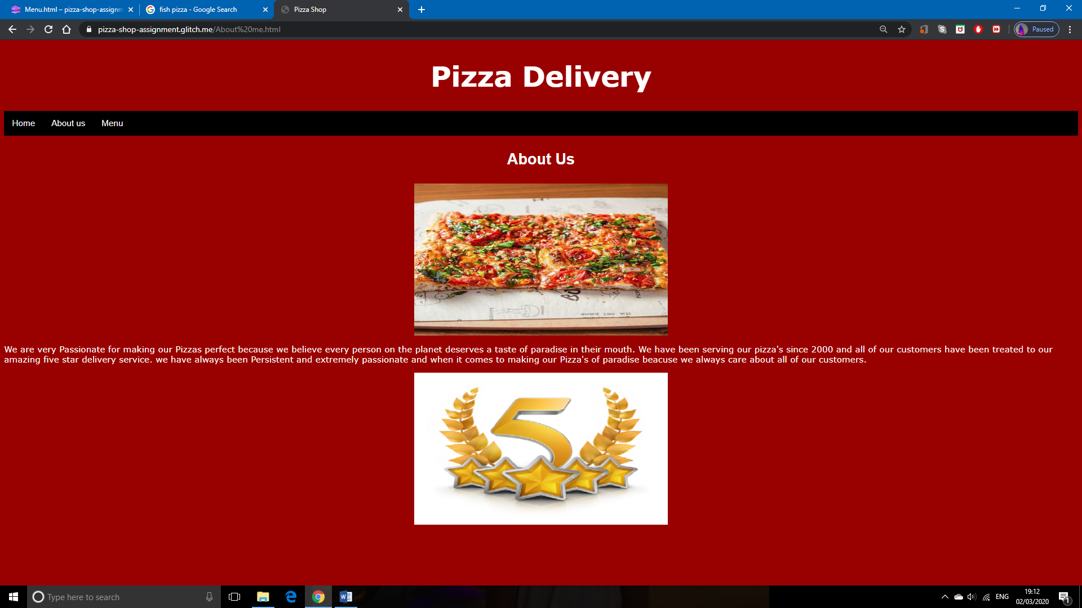

Next is the about us page. This educates the customers about our store and customer service.

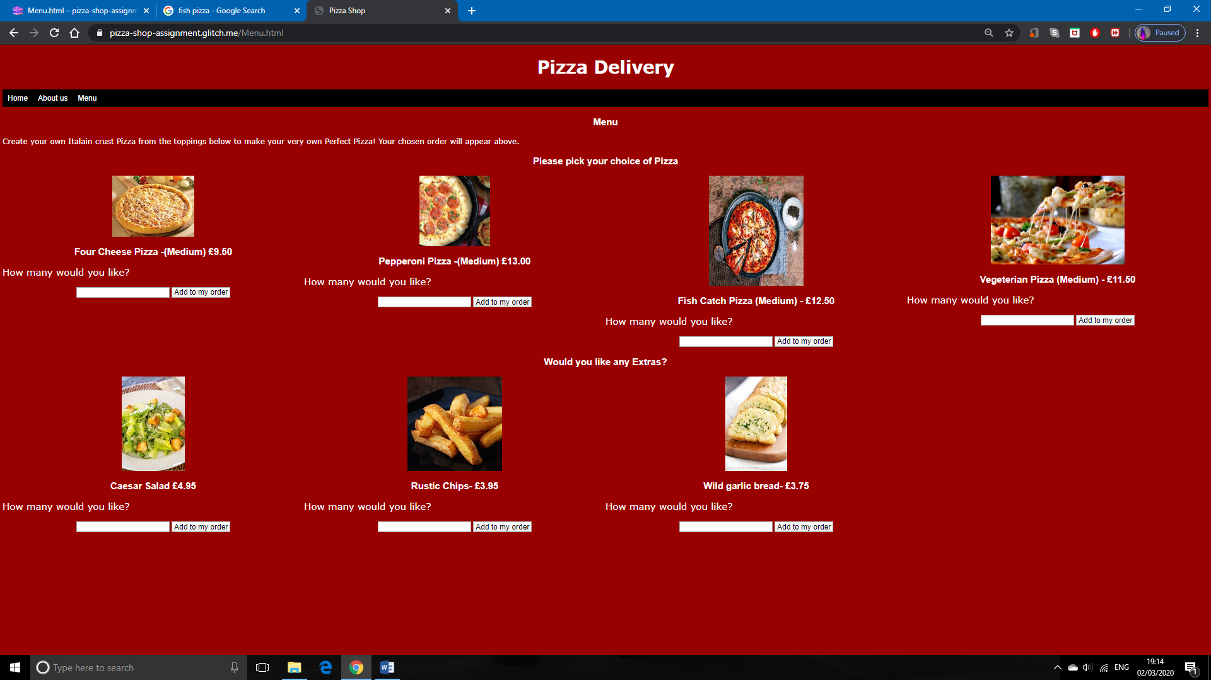The final page is the menu where the user can order their preferred pizza along with the extra choices. To do this they pick the order and then type in the quantity and then click the “Add to my order button” to receipt of their order will appear on the left hand corner.

Here is an example:

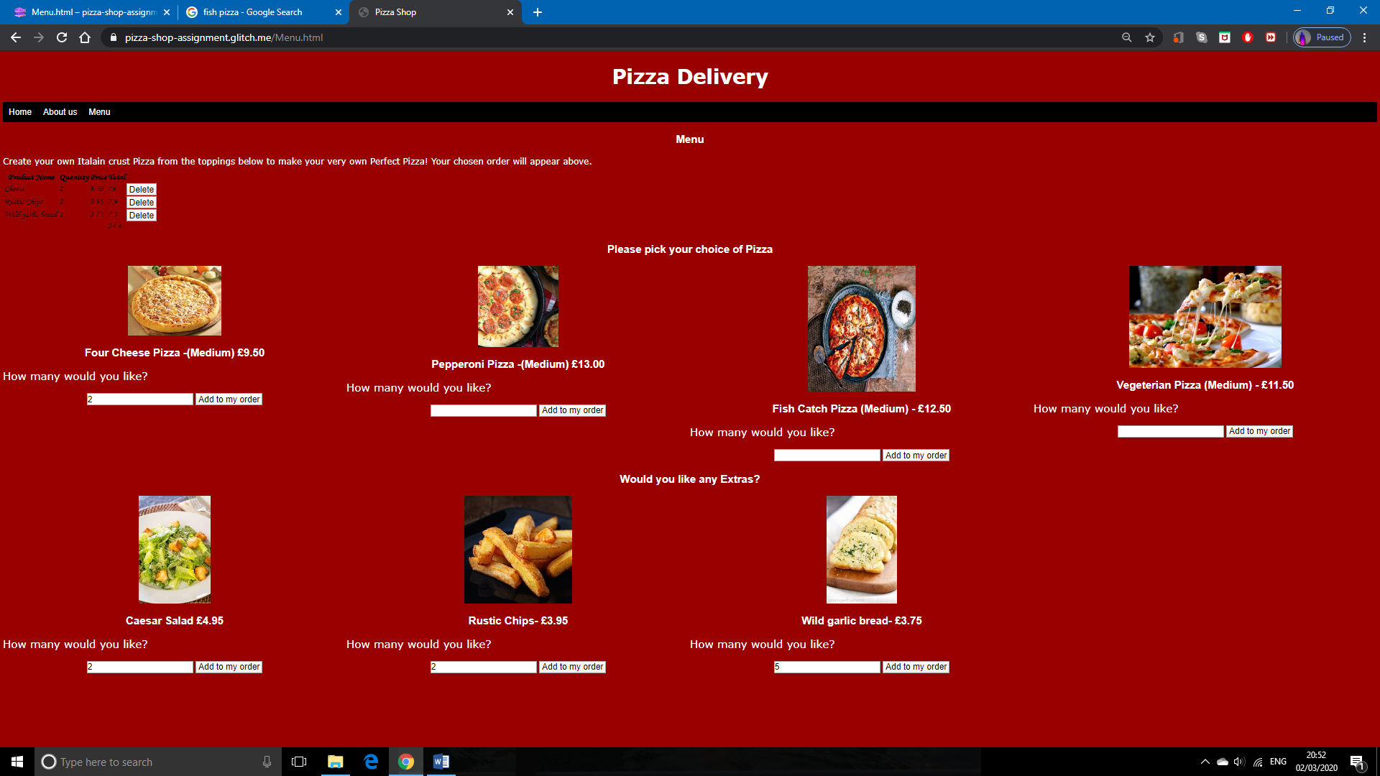

1. The user has picked 2 four cheese pizzas, 2 Caesar salads, 2 rustic chips and 5 garlic breads.
2. In the left hand corner there is the customer’s order which totals up the prices of each product so they can the total amount required when their order gets delivered to them.

**Screenshots of code:**

HTML:

Index page (Homepage):

**<!DOCTYPE html>**

**<html lang="en">**

**<head>**

**<title>Pizza Shop</title>**

**<meta charset="utf-8">**

**<meta http-equiv="X-UA-Compatible" content="IE=edge">**

**<meta name="viewport" content="width=device-width, initial-scale=1">**

**<link rel="stylesheet" href="/style.css">**<!---external link to CSS--->

**<script src="/script.js" defer></script>**<!---external link to javascript--->

**</head>**

**<body>**

**<h1>Pizza Delivery</h1>**

**<ul>** <!--Navigation of pages-->

**<li><a class="active" href="index.html">Home</a></li>**

**<li><a href="About me.html">About us</a></li>**

**<li><a href="Menu.html">Menu</a></li>**

**</ul>**

**<h3>Welcome!</h3>**

**<br>** <!--this is known as a line break tag. after the welcome in heading 3 there will be a gap before the image-->

**<img src="https://cdn.glitch.com/2ba4491d-82f0-461b-9869-b1b2ac74f315%2Fimages.jpg?v=1582746271114" width="500" height="300">** <!---//image link and scalling of image(internal CSS) --->

**<h3>Delivering your pizza with precision and pace!</h3>**

**</body>**

**</html>**

About us page:

**<!DOCTYPE html>**

**<html lang="en">**

**<head>**

**<title>Pizza Shop</title>**

**<meta charset="utf-8">**

**<meta http-equiv="X-UA-Compatible" content="IE=edge">**

**<meta name="viewport" content="width=device-width, initial-scale=1">**

**<link rel="stylesheet" href="/style.css">**<!---external link to CSS--->

**<script src="/script.js" defer></script>**<!---external link to javascript--->

**</head>**

**<body>**

**<h1>Pizza Delivery</h1>**

**<ul>** <!--Navigation bar-->

**<li><a class="active" href="index.html">Home</a></li>**

**<li><a href="About me.html">About us</a></li>**

**<li><a href="Menu.html">Menu</a></li>**

**</ul>**

**<h3>About Us</h3>**

**<img src="https://cdn.glitch.com/2ba4491d-82f0-461b-9869-b1b2ac74f315%2F37746585_670674176606405_3390093029049106432_n.jpg?v=1582826505124" width="500" height="300">** <!---//image link and scalling of image (internal CSS) --->

**<p> We are very Passionate for making our Pizzas perfect because we believe every person on the planet deserves a taste of paradise in their mouth. We have been serving our pizza's since 2000 and all of our customers have been treated to our amazing five star delivery service. we have always been Persistent and extremely passionate and when it comes to making our Pizza's of paradise beacuse we always care about all of our customers. </p>**

**<img src="https://www.gigsdy.com/wp-content/uploads/2019/06/0eee22832f35c393f27521e80804b2e04c87b0b5_New1-540x405.png" width="500" height="300**"**>**<!---//image link and scalling of image (internal CSS) --->

**</body>**

**</html>**

Menu page:

**!DOCTYPE html>**

**<html lang="en">**

**<head>**

**<title>Pizza Shop</title>**

**<meta charset="utf-8">**

**<meta http-equiv="X-UA-Compatible" content="IE=edge">**

**<meta name="viewport" content="width=device-width, initial-scale=1">**

**<link rel="stylesheet" href="/style.css">**<!---external link to CSS--->

**<script src="/script.js" defer></script>**<!---external link to javascript--->

**</head>**

**<body>**

**<h1>Pizza Delivery</h1>**

**<ul>** <!--Navigation bar-->

**<li><a class="active" href="index.html">Home</a></li>**

**<li><a href="About me.html">About us</a></li>**

**<li><a href="Menu.html">Menu</a></li>**

**</ul>**

**<h3>Menu</h3>**

**<p> Create your own Italain crust Pizza from the toppings below to make your very own Perfect Pizza! Your chosen order will appear above.</p>**

**<div id="cart"></div>**

**<section id="menu">**

**<div id="contentHeading">**

**<h3>Please pick your choice of Pizza</h3>**

**</div>**

**<div class="grid-container"> <!--Formats into a CSS grid-->**

**<div>**

**<img class src="https://cdn.shopify.com/s/files/1/1163/3506/products/24-hour-cheese-pizza-delivery.jpeg?v=1475846819">**

**<h3>Four Cheese Pizza -(Medium) £9.50</h3>**

**<p>How many would you like?</p>**

**<label for="item2quantity"></label><input type="number" id="item2quantity" >** <!-- Input box for the user to enter the quantity of pizza-->

**<button type="button" onclick="addCheese()">Add to my order</button>** <!-- button to add to the order-->

**</div>**

**<div>**

**<img class src="https://encrypted-tbn0.gstatic.com/images?q=tbn%3AANd9GcQa3jqTuf43YoiVeOo1UiyaFJeU8lKxKWi7dLxTJyT6CfejAj6f">**

**<h3>Pepperoni Pizza -(Medium) £13.00</h3>**

**<p>How many would you like?</p>**

**<label for="item3quantity"></label><input type="number" id="item3quantity" >** <!-- Input box for the user to enter the quantity of pizza-->

**<button type="button" onclick="addPepperoni()">Add to my order</button>** <!-- button to add to the order-->

**</div>**

**<div>**

**<img class src="https://www.fishisthedish.co.uk/assets/images/recipes/_headerImages/BENS-FISH-PIZZA.jpg" width="300" height="350">**

**<h3>Fish Catch Pizza (Medium) - £12.50</h3>**

**<p>How many would you like?</p>**

**<label for="item4quantity"></label><input type="number" id="item4quantity" >** <!-- Input box for the user to enter the quantity of pizza-->

**<button type="button" onclick="addFishcatch()">Add to my order</button>** <!-- button to add to the order-->

**</div>**

**<div>**

**<img class src="https://cdn.glitch.com/2ba4491d-82f0-461b-9869-b1b2ac74f315%2FItalian-pizza1.jpg?v=1582746274063">**

**<h3>Vegeterian Pizza (Medium) - £11.50</h3>**

**<p>How many would you like?</p>**

**<label for="item5quantity"></label><input type="number" id="item5quantity" >**<!-- Input box for the user to enter the quantity of pizza-->

**<button type="button" onclick="addvegeterian()">Add to my order</button>** <!-- button to add to the order-->

**</div>**

**</div>**

**<div class="menuExtrasHeading">**

**<h3>Would you like any Extras?</h3>**

**</div>**

**<div class="grid-container">** <!--Formats into a CSS grid-->

**<div>**

**<img class src="https://tse2.mm.bing.net/th?id=OIP.MZ8ZVFnECXNS2pK-QDD9UwHaLH&pid=Api&P=0&w=300&h=300"> <!--IMAGE LINK-->**

**<h3>Caesar Salad £4.95 </h3>**

**<p>How many would you like?</p>**

**<label for="extraitem1quantity"></label><input type="number" id="extraitem1quantity">** <!-- Input box for the user to enter the quantity of extras-->

**<button type="button" onclick="addCaesarSalad()">Add to my order</button>** <!-- button to add to the order-->

**</div>**

**<div>**

**<img class src="https://prendergastbutchers.co.uk/wp-content/uploads/2018/05/41147_P.jpg">**<!--IMAGE LINK-->

**<h3> Rustic Chips- £3.95</h3>**

**<p>How many would you like?</p>**

**<label for="extraitem2quantity"></label><input type="number" id="extraitem2quantity">**<!-- Input box for the user to enter the quantity of extras-->

**<button type="button" onclick="addRusticChips()">Add to my order</button>** <!-- button to add to the order-->

**</div>**

**<div>**

**<img class src="https://tse4.mm.bing.net/th?id=OIP.K4aBqf8vy09OOwFhVs5LQgHaLZ&pid=Api&P=0&w=300&h=300">**<!--IMAGE LINK-->

**<h3> Wild garlic bread- £3.75</h3>**

**<p>How many would you like?</p>**

**<label for="extraitem3quantity"></label><input type="number" id="extraitem3quantity">**<!-- Input box for the user to enter the quantity of extras-->

**<button type="button" onclick="addWildgarlicbread()">Add to my order</button>** <!-- button to add to the order-->

**</div>**

**</div>**

**<div>**

**</div>**

**</section>**

**</body>**

**</html>**

CSS:

**body{**

**background-color:#990000;** // dark red colour

**}**

**h1{**

**font-family: Verdana;**

**color: #ffffff;** // white colour text for the pizza delivery title

**text-align: center;** // places the title in the middle

**font-size:55px;**

**}**

**p{**

**font-family: Verdana;**

**color: #FFFFFF;** // white text for the about us writing

**text-align: Left;** //places the text on the left hand side

**}**

**h3{**

**font-family: Arial;**

**color: #ffffff;** // white text used on the homepage slogan and menu page

**font-size: 30px;**

**text-align: Center;** // both are placed in the middle

**}**

**ul { // nav bar**

**list-style-type: none;**

**margin: 0;**

**padding: 0;**

**overflow: hidden;**

**background-color: #000000;** // black colour nav bar

**font-family: Arial;**

**font-size:17px;**

**}**

**li {**

**float: left;** //the links to the pages will be formatted from the left hand side

**}**

**li a {**

**display: block;**

**color: #ffffff;**

**text-align: center;**

**padding: 14px 16px;**

**text-decoration: none;**

**}**

**li a:hover:not(.active) {**

**background-color: #FF0000;**

**}**

**.active {**

**background-color: #00000;**

**}**

**img{**

**Display:block;**

**margin-left:auto;**

**margin-right:auto;**

**}**

**.grid-container {**

**margin-top: 30px;**

**margin-bottom: 30px;**

**display: grid;**

**grid-template-columns: 25% 25% 25% 25%;**

**grid-gap: 0;**

**background-color:#990000 ;** //the grid is the same colour as the background of the **website**

**padding: 0 0 0;**

**}**

**.grid-container > div {**

**background-color:#990000 ;**

**text-align: center;** // all the text in the grid is all in the center

**font-size: 30px;**

**}**

**\* {box-sizing: border-box}**

**}**

JavaScript:

**var products; // declaring variables**

**var quantities;**

**var price;**

**products = [];** //arrays to store these 3 values when they are picked by the user

**quantities = [];**

**price = [];**

**function addCheese(){** // when the user picks cheese it adds it to the order

**products.push('Cheese');**

**quantities.push(parseInt(document.getElementById('item2quantity').value));**

**price.push("9.50");**

**displayCart();** // displays cheese in the cart if the user picks it

**}**

**function addPepperoni(){** // When the user picks Pepperoni it adds it to the order

**products.push("Pepperoni ");**

**quantities.push(parseInt(document.getElementById('item2quantity').value));**

**price.push("13.00");**

**displayCart();**// displays pepperoni in the cart if the user picks it

**}**

**function addFishcatch(){**// When the user picks fish catch it adds it to the order

**products.push("Fish Catch ");**

**quantities.push(parseInt(document.getElementById('item3quantity').value));**

**price.push("12.50");**

**displayCart();**// displays fish catch in the cart if the user picks it

**}**

**function addvegeterian(){**// When the user picks vegeterian it adds it to the order

**products.push("vegeterian");**

**quantities.push(parseInt(document.getElementById('extraitem1quantity').value));**

**price.push("11.50");**

**displayCart();**// displays vegeterian in the cart if the user picks it

**}**

**function addCaesarSalad(){** // When the user picks caesar salad it adds it to the order

**products.push("Caesar Salad");**

**quantities.push(parseInt(document.getElementById('extraitem2quantity').value));**

**price.push("4.95");**

**displayCart();**// displays caesar salad in the cart if the user picks it

**}**

**function addRusticChips(){**// When the user picks rustic chips it adds it to the order

**products.push("Rustic Chips");**

**quantities.push(parseInt(document.getElementById('extraitem2quantity').value));**

**price.push("3.95");**

**displayCart();**// displays rustic chips in the cart if the user picks it

**}**

**function addWildgarlicbread(){**// When the user picks garlic bread it adds it to the order

**products.push("Wild garlic bread");**

**quantities.push(parseInt(document.getElementById('extraitem2quantity').value));**

**price.push("3.75");**

**displayCart();** // displays wild garlic bread in the cart if the user picks it

**}**

**function displayCart(){** // displays the customers order

**let cartdata = '<table><tr><th>Product Name</th><th>Quantity</th><th>Price</th><th>Total</th></tr>';** // the users order will displayed in a table

**let total = 0;**

**for (let i=0; i<products.length; i++){**

**total += quantities[i] * price[i];**

**cartdata += "<tr><td>" + products[i] + "</td><td>" + quantities[i] + "</td><td>" + price[i] + "</td><td>" + quantities[i] * price[i] + "</td><td><button onclick='delElement(" + i + ")'>Delete</button></td></tr>"**

**}**

**cartdata += '<tr><td></td><td></td><td></td><td>' + total + '</td></tr></table>';// gives a total of the order so the customer knows what to pay**

**document.getElementById('cart').innerHTML = cartdata**

**}**

**function delElement(a){**

**products.splice(a, 1);**

**quantities.splice(a, 1);**

**price.splice(a, 1);**

**displayCart()**

**}**

**Testing and Evaluation:**

**Google chrome page look:**

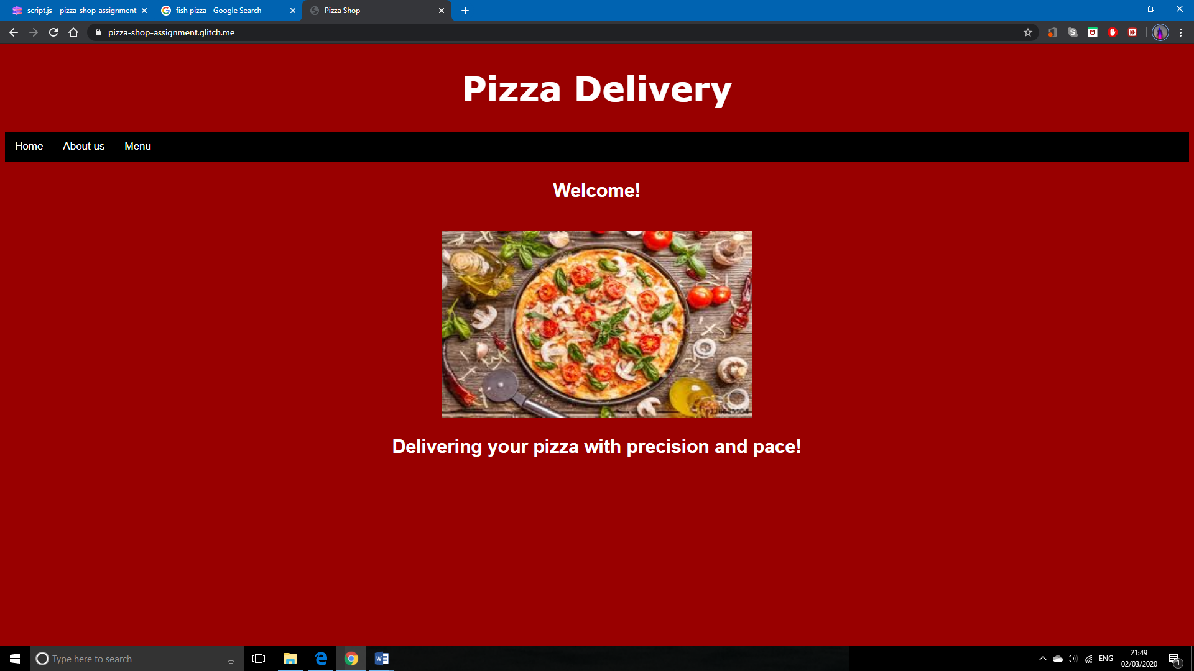

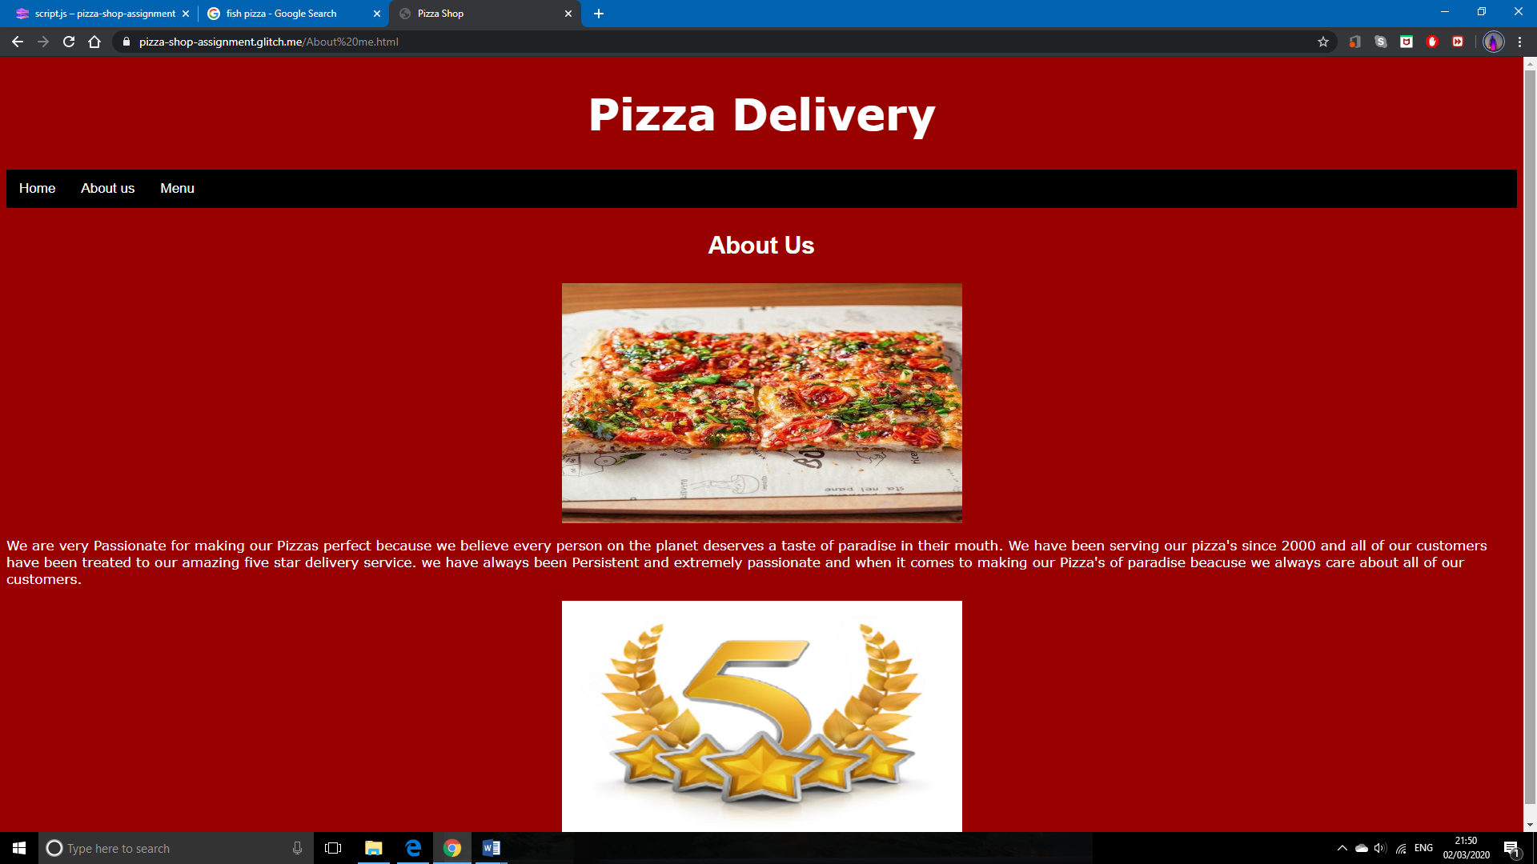

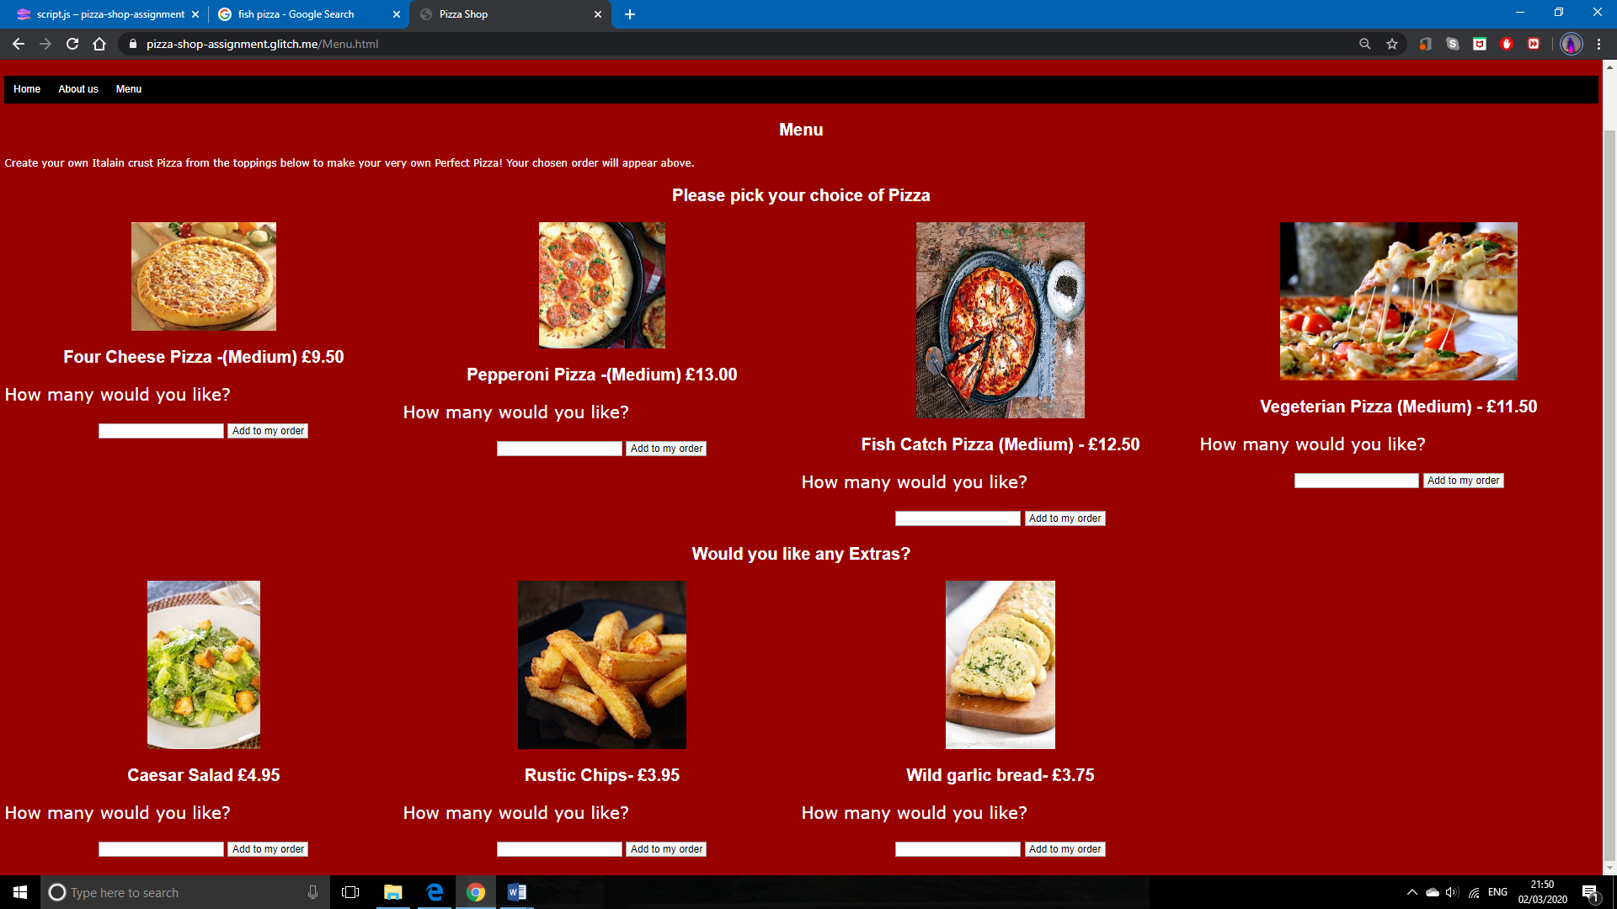

Edge look:

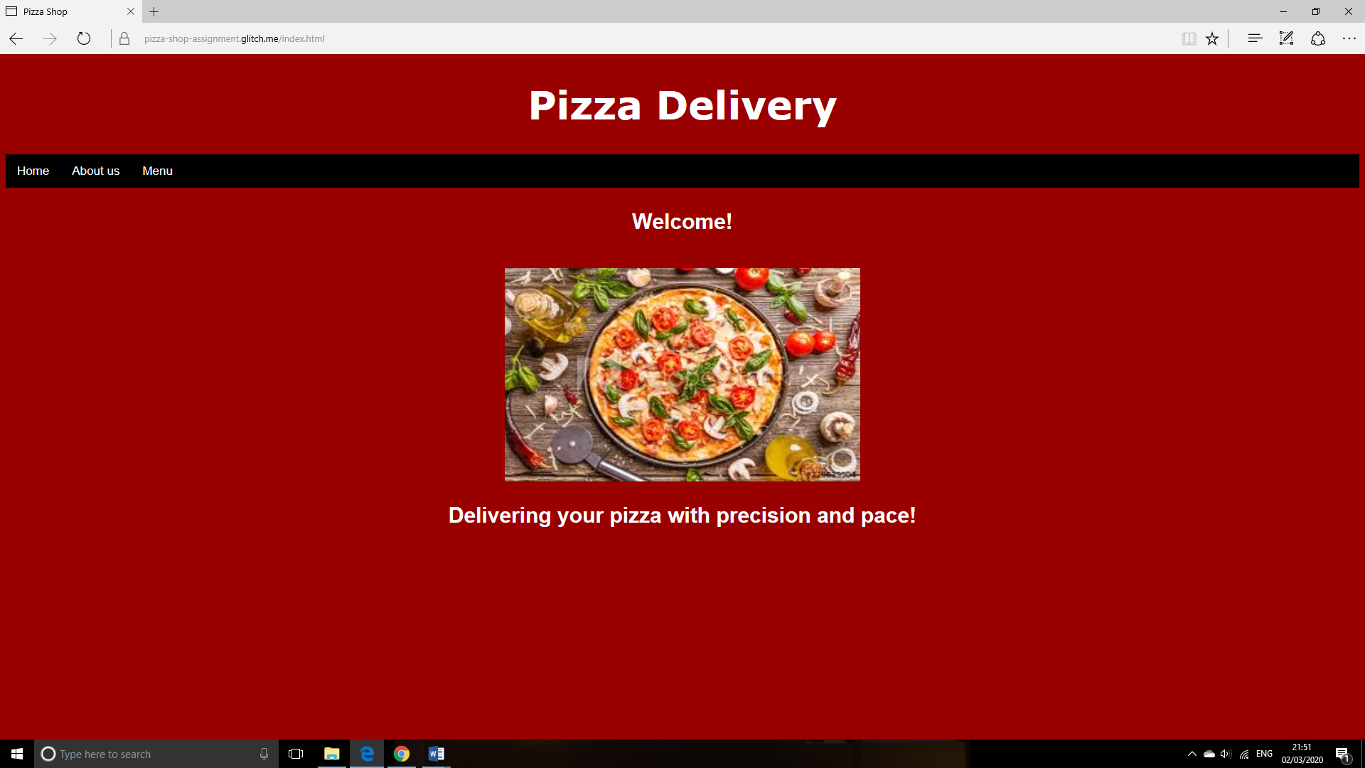

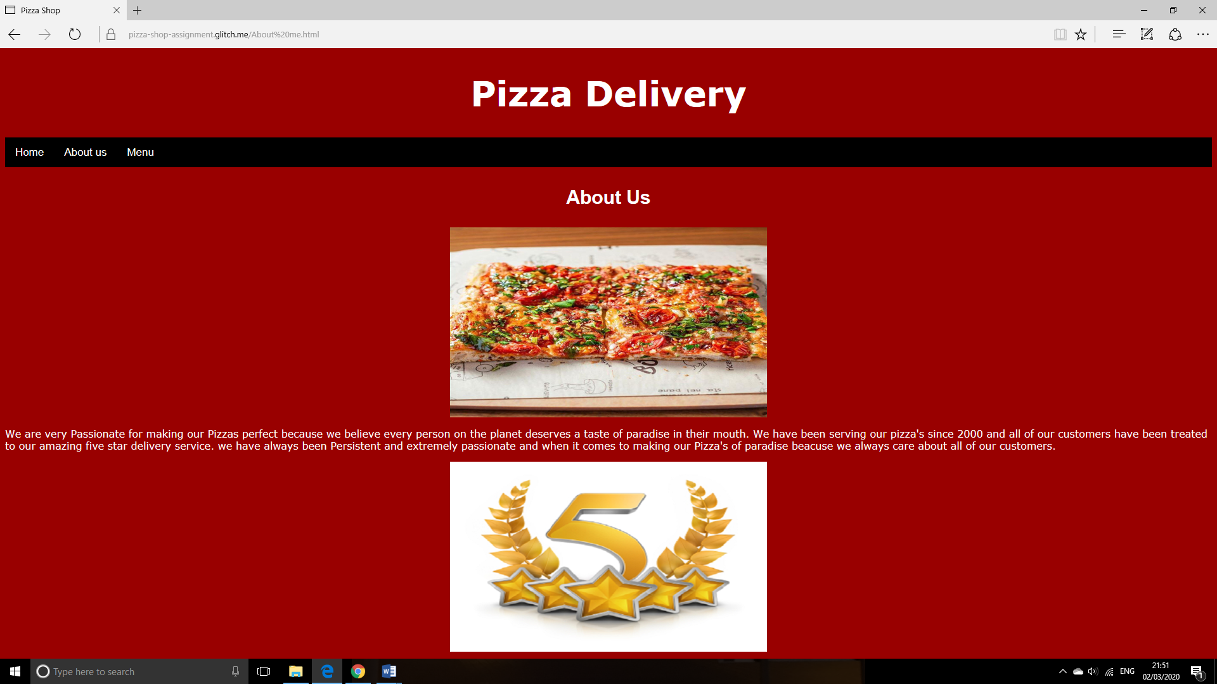

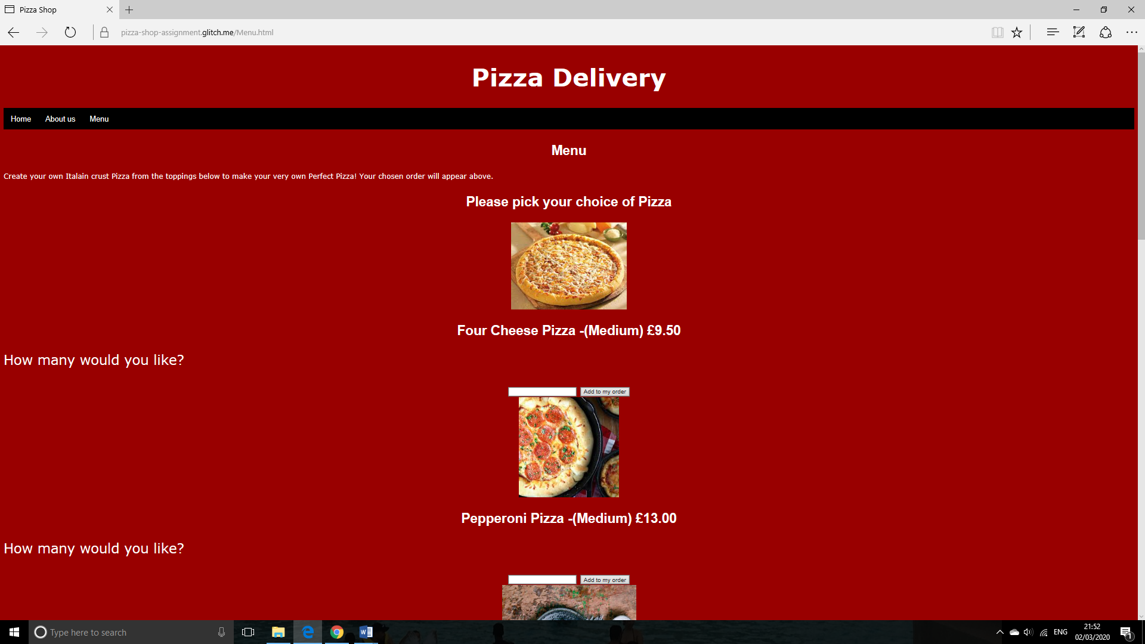

Also the input box that allows the user to input the quantity and the add to my order button requires to go under the question and also it needs a gap between the next picture.

Image and writing in middle. Also the question to the user is on the left and is not in line with the picture and information on the pizza, size and price.

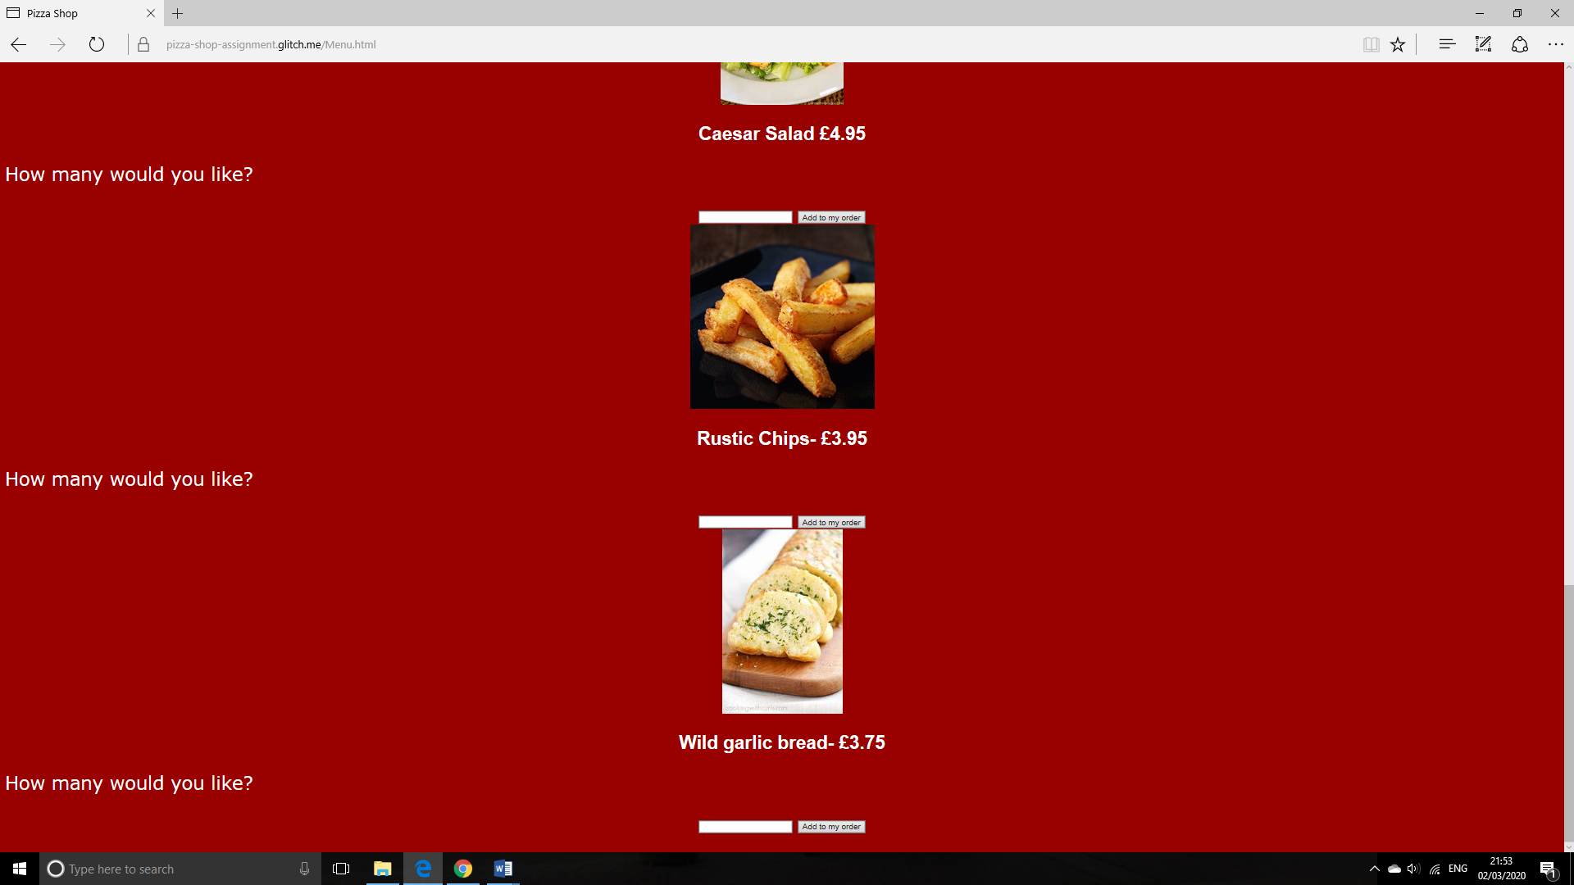

Firefox look:

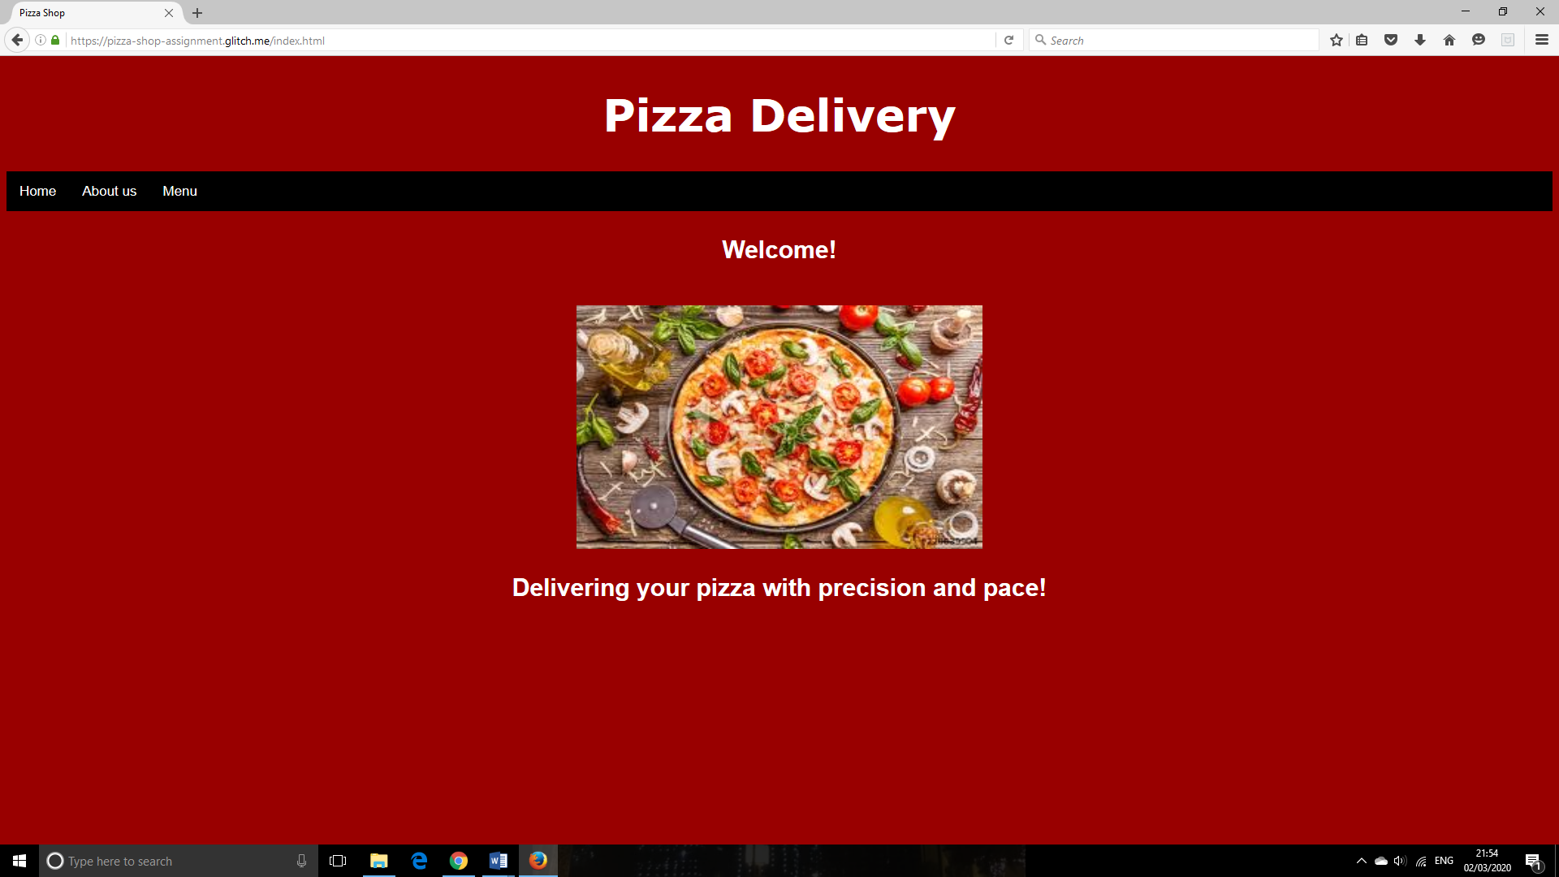

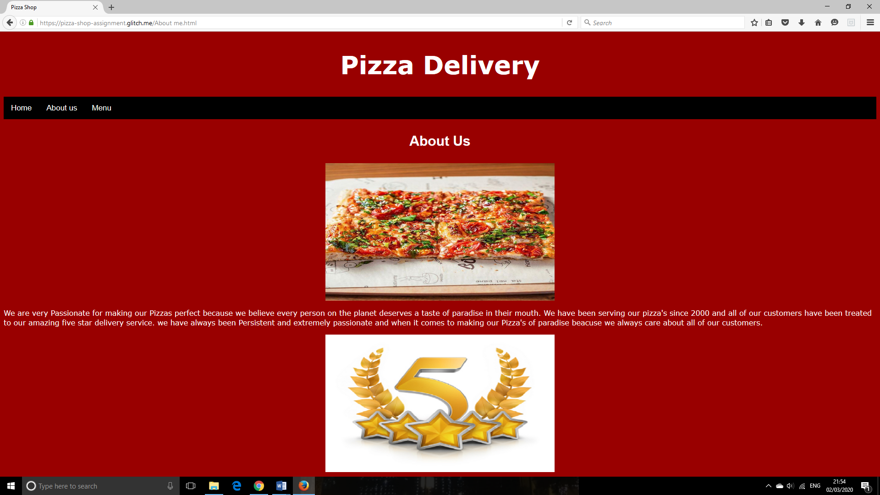

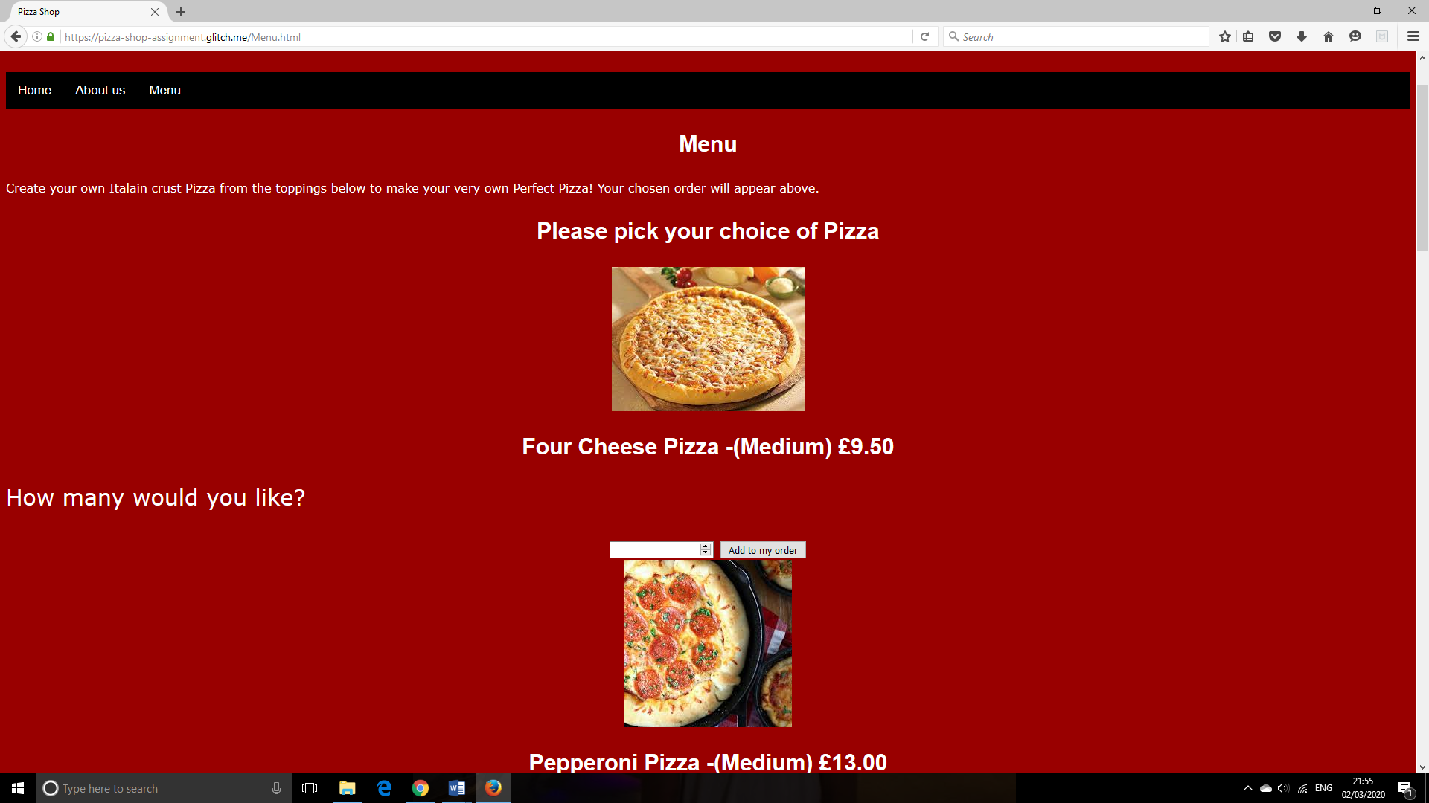

Image and writing in middle. Also the question to the user is on the left and is not in line with the picture and information on the pizza, size and price.

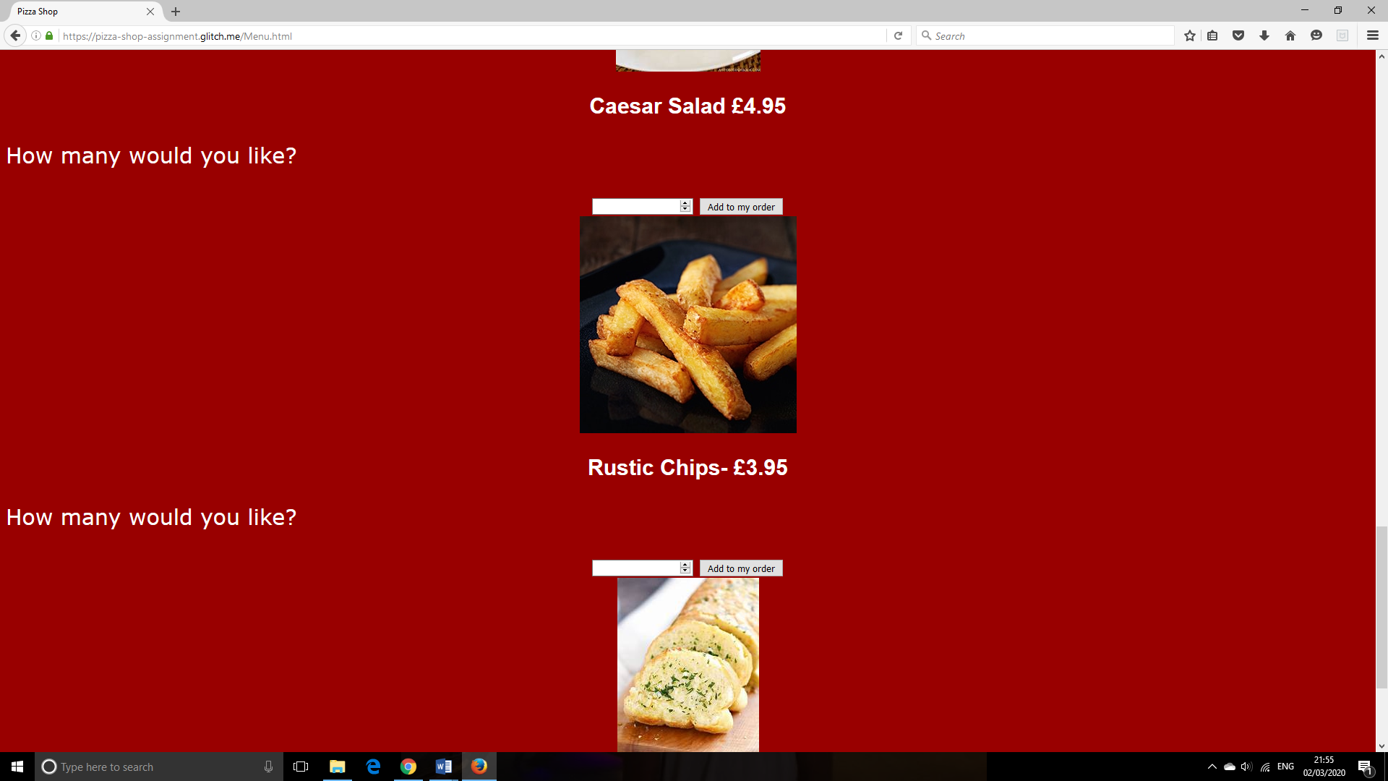

Also the input box that allows the user to input the quantity and the add to my order button requires to go under the question and also it needs a gap between the next picture.

On all 3 browsers the homepage and about us page are all the same. However, on Google Chrome the menu is formatted in a presentable manner compared to Edge and Firefox which are both presented in a different matter due to the browser interpretation of the code.

**Black Box Testing:**

|  |  |  |  |  |  |
| --- | --- | --- | --- | --- | --- |
| Test Number | Component  Being tested | Test data input | Test type | Expected outcome | Official  Outcome |
| 1 | Quantity input | 2 | Accepted | 2 | 2 |
| 2 | Quantity  input | sdf | Data unaccepted | No output | No output |
| 3 | Quantity input | 0.5 | Accepted | 0 | 0 |
| 4 | Quantity input | 0+10 | Accepted | Nan | Nan |
| 5 | Quantity input | -5 | Accepted | -5 | -5 |
| 6 | Quantity input | 1300 | Accepted | 1300 | 1300 |

**UX evaluation:**

Overall, my Pizza delivery website meets the client’s requirements. The user requirements were the pizza had to show the topping so the customer knows what to order. Also, the company wanted the total price visible to their customers so when the customers chooses different pizza and extras it shows the information for that also along with final amount which customers will pay upon the delivery of their order.

In my Pizza delivery website, I used three HTML forms which presented catchy slogan on the homepage to attract customers. On the second form there was brief information to educate new customers about the Pizza delivery business. Finally, on the last form was the menu which allows the user to make their order.

On the menu form I used JavaScript to make the website interactive for the customers. I used an input box for the user to input the quantity of pizza and extras. I also made a button so when the user clicks on the button it will confirm their order.

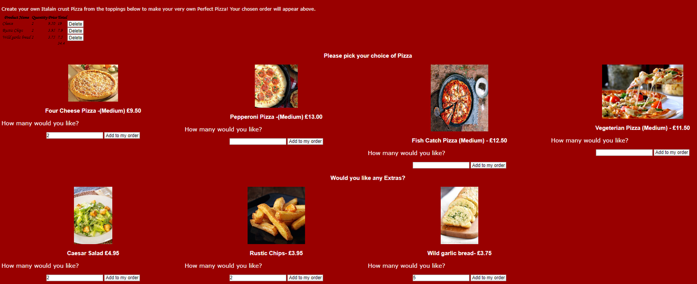

Also I made a delete button for the user to deselect anything if they wanted to change the quantity or food.

Finally, I used CSS to format my website to enhance and make the foods, price and company name to the customers look presentable.

The end user found the website very appealing and they also found very simple and easy to use and navigate between different pages.

To improve this Pizza delivery website, I could implement a contact page which makes them include their name, email and then their review so the customers can give their verdict on their pizza. There can also be FAQ section on the contact page for customer service improvements along with the phone number and email of the store so customers can contact the store on any problems they have. This would be useful as it will improve the business and also guide the business towards future success.

Also some users requested a drinks section on the Menu page so customers have that option to buy drinks with their order. These drinks could be Pepsi, Fanta, Rubicon, Rio etc. when the user picks these drinks it should show it in the order box at the top of the page.

Finally, there can also be deserts such as Cookie dough and Ice cream so customers can have that extra option if they rather have something sweet than eating savoury.